Scenario 1: Delivery Time Analysis for an E-commerce Company
Ramishahope Artificial Intelligence Pvt Ltd
36, Old Anandas, SG Arcade, Marudhamalai Main Road, Vadavalli, Coimbatore -641041.
+91 6385383227 | www.hopelearning.net | mdaravind@hopelearning.net | 33AAMCR3722R1ZU
An e-commerce company tracks delivery times (in minutes) for 15 orders:
[25, 30, 35, 40, 45, 50, 55, 60, 65, 70, 75, 80, 85, 90, 95]
The company wants to analyze the delivery performance using percentiles and detect if there are any unusual delivery times.
Question 1:
Calculate Q1 and Q3.
Using np.percentile(data,25) and np.percentile(data,75) we can find it
Q1=40
Q3=80
Question 2:
Find the Interquartile Range (IQR).
IQR= Q3-Q1 = 80-40=40
Question 3:
Detect Outliers using the IQR method.
Lower bound outlier = Q1-(1.5*IQR) = -20
Upper bound outlier = Q3+(1.5*IQR) = 140

There is NO OUTLIERS in the e-commerce company tracks delivery times data

Scenario 2: Student Score Analysis
A teacher is analyzing the mathematics scores of students in her class. The scores are:
[45, 50, 55, 60, 60, 62, 63, 65, 90, 95]
Question 1:
Calculate the mean, median, and mode of the scores.
Mean=64.5
Median=61
Mode=60
Question 2:
Explain why the median might be a better representation than the mean in this case.
Because median excludes the outliers and calculated the accurate central tendency for the data
But mean may include outliers in the calculation leads to inaccurate central tendency of data. So median is better representation for central tendency

Scenario 3: Grocery Store Customer Analysis
A grocery store manager tracks how many customers visit the store daily for a month:
[5, 10, 8, 15, 20, 5, 12, 14, 10, 18]
Question 1:
Create a frequency distribution table for this data.
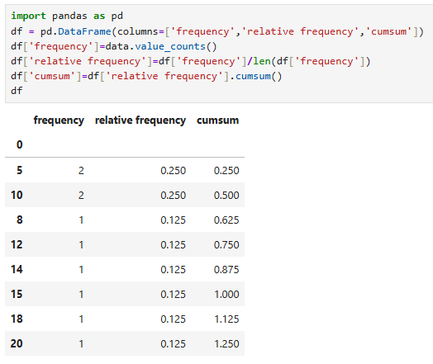

Scenario 4: Real Estate Model Analysis
Ramishahope Artificial Intelligence Pvt Ltd
36, Old Anandas, SG Arcade, Marudhamalai Main Road, Vadavalli, Coimbatore -641041.
+91 6385383227 | www.hopelearning.net | mdaravind@hopelearning.net | 33AAMCR3722R1ZU
A real estate model has three variables:
- House Size
- Number of Rooms
- Number of Bathrooms
Question 1:
How can you detect multicollinearity in this model?
To detect multicollinearity in a real estate model with variables such as house size, number of rooms, and number of bathrooms, we can use a pair plot to visualize the relationships between these variables. A pair plot helps in identifying correlations by showing scatter plots for each variable combination.
If two or more independent variables are highly correlated, it indicates the presence of multicollinearity in the model. In this case, we can reasonably assume that as house size increases, the number of rooms and bathrooms also tends to increase. This suggests a strong correlation among these variables, which may lead to multicollinearity.

Scenario 5: Medicine Effectiveness Study
A company made a new medicine to lower blood pressure. They gave it to one group and gave a fake pill (placebo) to another group.
Question 1:
How can the company check if the new medicine works?
To determine whether a new medicine for lowering blood pressure is effective, the company can conduct an experiment by dividing participants into two groups: one group receives the actual medicine (treatment group), while the other receives a placebo (control group).
To evaluate the effectiveness, we use hypothesis testing:
- Null Hypothesis (H₀): The medicine has no effect; there is no difference in blood pressure between the two groups.
- Alternative Hypothesis (H₁): The medicine has an effect; there is a significant difference between the two groups.
After collecting the data, we calculate the p-value to test for statistical significance.
- If the p-value < 0.05, we reject the null hypothesis and conclude that the medicine has a significant effect on lowering blood pressure.
- If the p-value ≥ 0.05, we fail to reject the null hypothesis, meaning there is no sufficient evidence to say the medicine is effective.
Thus, by comparing the results of both groups using hypothesis testing, the company can determine whether the new medicine works.

Scenario 6: Identifying Outliers in Sales Data
A company wants to find any unusual spikes in sales.
Question 1:
How can the company detect outliers in their sales data?
To identify unusual spikes in sales, a company can analyze outliers in its sales data. One way to understand the presence of outliers is by examining the kurtosis of the distribution.
Kurtosis measures the “tailedness” of the data distribution and helps indicate the likelihood of extreme values:
- If kurtosis > 3 (leptokurtic), the distribution has sharper peaks and heavier tails, indicating a higher chance of outliers (extreme sales spikes).
- If kurtosis < 3 (platykurtic), the distribution is flatter with lighter tails, suggesting fewer outliers.
- If kurtosis = 3 (mesokurtic), the distribution is similar to a normal distribution with a moderate level of outliers.
By analyzing the kurtosis value, the company can understand whether the sales data is prone to extreme spikes. However, kurtosis alone does not directly identify specific outliers—it only indicates their likelihood. To detect actual outliers, additional methods such as the IQR method or Z-score analysis should be used.

Scenario 7: Understanding Customer Satisfaction
A restaurant conducted a survey to rate customer satisfaction on a scale of 1 to 5:
[5, 4, 4, 5, 3, 4, 5, 2, 4, 3]
Question 1:
How can the restaurant summarize the overall satisfaction?
To summarize overall customer satisfaction from a survey (rated 1 to 5 over 10 days), the restaurant can calculate central tendency measures:
- Mean (average rating): Adds up all ratings and divides by the total number of responses. This gives a general idea of overall satisfaction.
- Median (middle value): Identifies the middle rating when all responses are sorted. This is useful if the data has outliers.
By using these metrics, the restaurant can report an overall satisfaction score
